

SECP2523 – DATABASE SEM 1 - 2024/2025

Faculty of Computing

INITIAL SYSTEM PROPOSAL
SYSTEM KADA

Group Name: <TechMedico>
Members:
1. Elijah She Yu Sheng A23CS0073 (leader)

2. Choh Jing Yi A23CS0296

3. Lee Yin Shen A23CS0236

4. Joanne Ching Yin Xuan A23CS0227

5. Lim Yu Han A23CS0241
Stakeholder:
Lembaga Kemajuan Pertanian Kemubu (KADA)

Representative Name | Date Interviewed

PROPOSED SYSTEM BACKGROUND

Introduction
Farmers in Malaysia especially those live in Kemubu region frequently struggle to raise the money they need to start making money and make investments in new equipment or technology. Since many farmers particularly in developing nations who are lack access to credit or finance that is suitable to their specific needs [1]. However, the KADA system is outdated and finds it difficult to adapt to modern technologies. When it comes to handling registrations, it is ineffective since paper forms remain in use rather than a more efficient digital platform. Users become frustrated as a result of the procedure being slow and easy to make mistakes.

Our group, ABC has decided to create an online registration system to replace the KADA manual registration system. Employees must manually complete a form in order to register as KADA cooperative members under the existing system. This outdated approach is challenging to use and leads to many mistakes and inefficiency. Employees are discouraged from enrolling due to the cumbersome process, as they may find it too complex or inconvenient. Apart from the problems with the registration procedure, the cooperative's existing membership ceiling of 500 members severely restricts the number of employees who are eligible to register. The workforce surpasses the membership cap, which prevents many prospective employees from joining and taking advantage of the cooperative's financial benefits. Before, manual registration wasn't thought of as issues, but as technology advanced, things changed.

In addition, our group determined that the proposed system would be a cross-platform, cloud-based solution that can be accessed via mobile and online apps. The system will automate the registration process, allowing employees to easily sign up as members of the KADA cooperative through an intuitive online form. Employees will no longer need to use paper-based forms to complete the e-registration form, they need to use e registration form to upload the necessary files, and submit their information for approval. After a user registers, the system will automatically monitor their membership status and eligibility for a number of financial incentives including retirement savings programs and loans. Members will also be able to apply for loans, examine and manage their financial contributions, and monitor their payment statuses in real time. By removing the 500-member cap, the system will ease membership growth and allow an unlimited number of employees to sign up.

There are many benefits to our proposed system. First of all, the system provides a fast, efficient, and user-friendly way to register and access the cooperative's financial services, including loans, savings plans, and retirement funds. Employees can sign up for memberships online by automating the registration process, which reduces the possibility of mistakes and eliminates the need for paper-based forms. The registration process will be easier to use and save time, especially for employees who may have previously found it challenging or cumbersome. Moreover, with the ideology of Industry 4.0, everyone can now access the internet and share or retrieve information online, making the registration process more accessible and in line with modern digital practices [2]. Additionally, the cloud-based platform of the system gives employees more transparency and control over their money by enabling them to apply for loans, manage their membership status, and keep an eye on their financial contributions in real-time. More employees will be able to join the cooperative and take advantage of these financial resources since the maximum 500 member has been removed hence improving their overall financial stability.

Actually, nowadays they are some system or platform that has been created such as Koperasi Rakyat Malaysia (KRM) [3]. However, there are some differences between KRM existing system and our proposed system. For instance, the KRM system uses traditional membership management that member needs to fill form manually, which can be complicated and easy to make mistakes because it depends on human processes. On the other hand, our suggested system makes it easier to use and more accessible by automating the entire registration and membership management process and enabling online registration using a cloud-based, cross-platform solution. In addition, our proposed system provides real-time financial management and tracking, making it simple for employee to keep an eye on their contributions, savings, and loan status which the feature that KRM's platform not fully integrate.

The Existing System

The cooperative (koperasi) run by Lembaga Kemajuan Pertanian Kemubu (KADA) offers significant benefits to its members, such as farming training, loan application, and lots of agricultural programs. However, there are some critical problems need to be solved in order to make this system more user-friendly and efficient for the users.

The first problem is cumbersome manual registration process. KADA currently offer an entirely manual registration process, whatever during membership registration, loan application or program registration. The users should download the form from the website, then manually fill them, and then submit it to nearby KADA branch. Thie process often results in wrong information, which will cause inefficient and time-consuming. Moreover, the registration form only available in Malay language, which will give poor user experience for those who are not proficient of the language. As the result, the KADA’s reach is restricted, which prevent a diverse group of users from joining and benefiting from its system.

Furthermore, the other problem is the lack of clear instruction of the system. For example, for a new user, they will only see a complicated interface. They is no a clear instruction for user to understand how to become a member, apply for loan, check their registration status and apply for farming program. The lack of guidance will leads to inefficient as the users may not understand the process involved, lead to incomplete application or miss opportunities.

The next problem is the membership cap. The KADA currently has a cap of only 500 member, which limit the number of users who can get benefit from their services. Under this cap, many users unable to register and access the KADA financial benefits like loan. This restriction also limits the growth and development of the KADA organization.

Lastly, one of the main problems is the lacking of financial transparency and reporting. Currently, the KADA does not provide complete month-end or year-end financial reports, include the profit and loss statements to members. As the result, members are unable to track the organization’s financial health and understand how their contributions are being managed. This will create a sense of uncertainty and mistrust among members.
These four problems which consists of manual registration, membership cap, unclear website instructions and lack of financial transparency will hinder the KADA ability to serve its members efficiently and inclusively. By addressing these problems, that will enhance the accessibility and improve the KADA operations and reach.

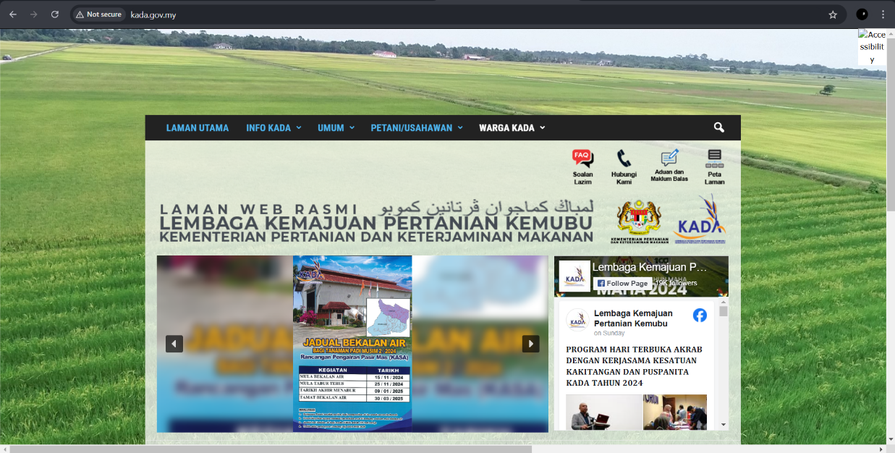

Figure 1: Main Page of KADA

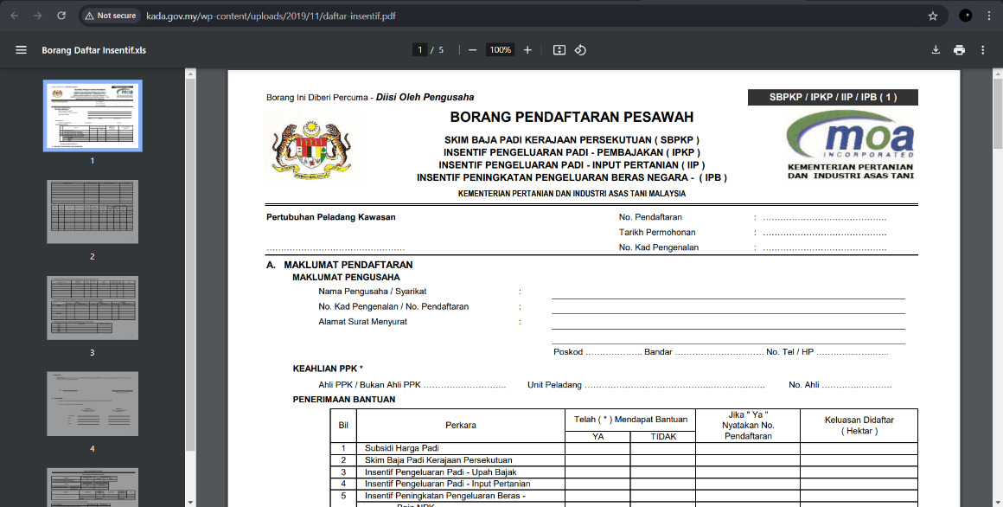

Figure 2: Manual Form Registration

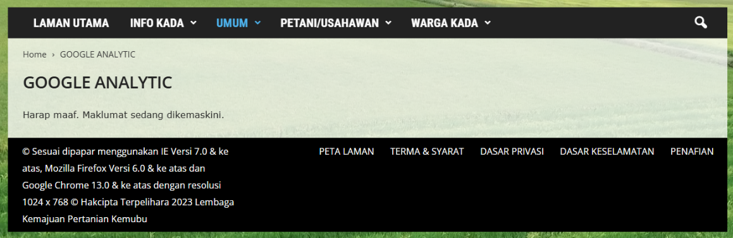
Figure 3: Google Analytic Missing

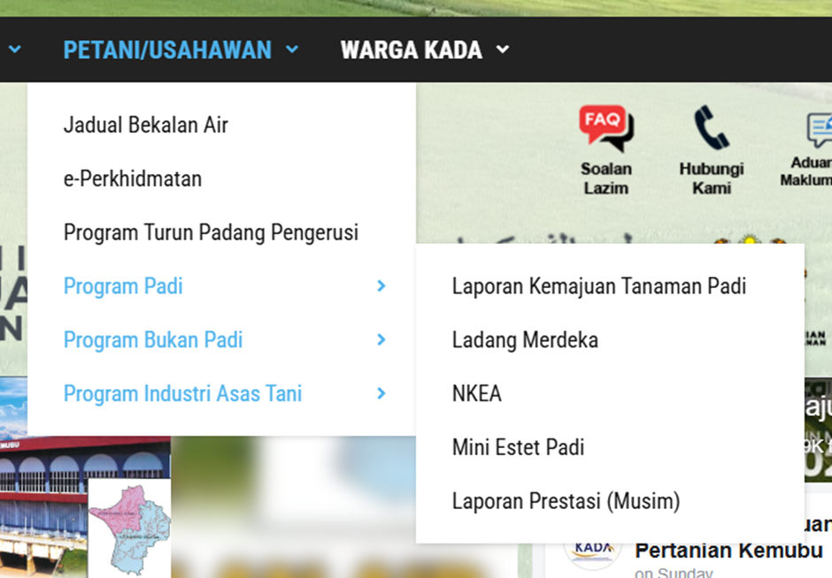
Figure 3: Google Analytic Missing

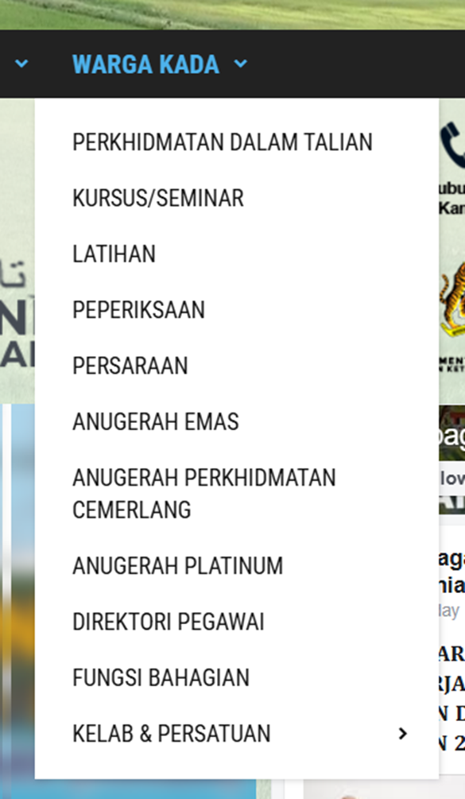

Figure 4: Dazzling Selection

Feature | Lembaga Kemajuan Pertanian Kemubu (KADA) | Lembaga Pertubuhan Peladang (LPP) | Perbadanana Pembangunan Pertaninan Negeri Perak (PPPNP)
Online Registration Process | No | Yes | Yes
Multiple System Language | No | No | Yes
Clear Instruction for New Users | No | Yes | Yes
Saving Account | No | No | No
Online Loan/Program Application | No | Yes | Yes
Financial Transparency (Reports) | No | Yes | Yes

The Proposed System

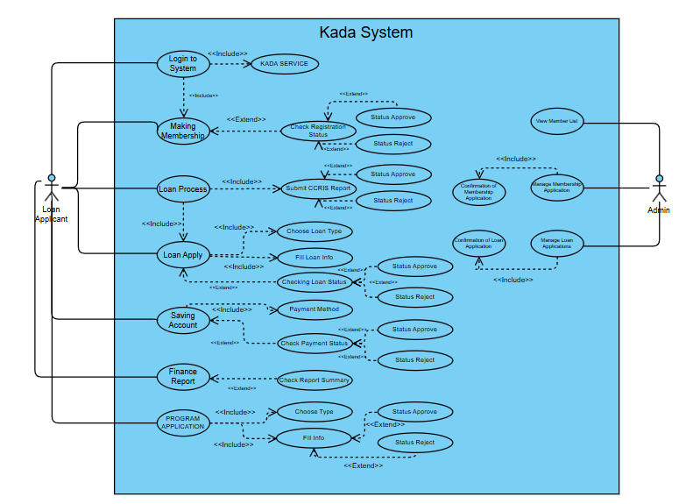

Figure 5: Use Case Diagram for KADA System

Objective
Our mission is to revolutionize the KADA cooperative registration system by replacing the outdated manual process with an efficient, cloud-based platform. This new system will simplify the registration process, making it faster, more user-friendly, and accessible across various devices. By eliminating the reliance on paper forms and introducing an automated digital workflow, we aim to reduce errors, save time, and provide users ,employees and staffs in the Kemubu region with a seamless way to join and benefit from the cooperative.
The main objectives of our proposed system are as follows:
1. To automate the registration process, enabling employees to sign up easily and efficiently through a cloud-based platform.
2. To eliminate the current membership ceiling, allowing an unlimited number of employees to join and benefit from the cooperative.
3. To provide real-time financial management features, including loan applications, savings plan, and payment monitoring.
4. To align the cooperative with Industry 4.0 principles, ensuring it remains competitive and relevant in a modern, digital economy.
Our ultimate goal is to support the economic and technological advancement of the agricultural sector by enhancing financial accessibility and transparency for cooperative members. This initiative will improve the overall financial stability of farmers and employees, contributing to the growth of the agricultural community in Malaysia while fostering inclusivity and innovation.

Scope
In this project, we have to develop eight main use cases.

1. Apply Membership
- Implement an online membership application module that allow users to register as KADA cooperative members.
- Collect relevant documents and personal information from applications for verification during the registration process.
- Notify users with their registration status, whether approved or rejected with instructions for further actions.
- Actor Involved: User, Admin

2. Apply Loan
- Enable members to apply for loans by selecting loan types and filling out required loan details.
- Allow members to track the status of their loan applications in real time.
- Notify applicants of approval or rejection and provide reasons and next steps for rejected applications.
- Actor Involved: Member, Admin

3. Apply Program
- Provide a module for members to browse, select and apply for the KADA programs.
- Collect required details for program application and facilitate submission.
- Notify users with their registration status, whether approved or rejected with instructions for further actions.
- Actor Involved: Member, Admin

4. Manage Saving Account
- Implement a savings account management feature to enable members to monitor and manage the payments related to loan, deposit and application.
- Allow members to select payment methods, track payment status and download receipt of successful transaction.
- Allow members to pay program application.
- Provide feedback on rejected or failed transactions and guidance for resolution.
- Actor Involved: Member, Admin

5. Create Finance Report
- Develop a reporting module allowing members to generate summaries of their financial activities, such as loan balances and payment histories.
- Enable members to view and download detailed financial reports for personal tracking and transparency.
- Provide admins access to these reports for monitoring overall financial activities and ensuring compliance with organizational policies.
- Actor Involved: Member, Admin

6. Approve Membership Registration
- Allow admins to review, confirm or reject membership applications submitted by users.
- Maintain a detailed list of all approved and pending members for future reference.
- Notify applicants of the approval status along with guidance for further actions if needed.
- Actor Involved: Admin

7. Approve Loan Application
- Provide admins the ability to review loan applications and approve or reject them based on the required criteria.
- Ensure compliance with organizational policies during the loan approval process.
- Notify members of the loan application decision with appropriate reasoning or next steps.
- Actor Involved: Admin

8. Approve Program Application
- Facilitate the review and approval/rejection of program applications submitted by members.
- Ensure all applications are processed fairly and efficiently.
- Notify members of their program application status with feedback or instruction if necessary.
- Actor Involved: Admin

Glossary

Term | Definition
KADA | Lembaga Kemajuan Pertanian Kemubu (Kemubu Agricultural Development Authority) – A Malaysian cooperative organization that provides support to farmers through training, loan application and agricultural program.
Manual Registration | A traditional process of registering users or members by filling out physical forms and submitting them to designated locations, often prone to errors and inefficiencies.
Cloud-Based System | A software application hosted on cloud servers, enabling users to access it from any device with an internet connection.
Membership Cap | A limit on the number of members an organization can accept, restricting the number of people who can benefit from its services.
Industry 4.0 | A term referring to the fourth industrial revolution, characterized by digital transformation and the integration of smart technologies into processes and systems.
Cross-Platform Solution | A software application that can operate on multiple types of devices or operating systems, such as mobile phones, tablets, and desktops.
Financial Incentives | Monetary benefits, such as savings programs, loans, or subsidies, provided to members to support their financial stability and growth.

Bibliography

[1] Common Problems and Challenges Faced by Farmers. (n.d.). Retrieved from https://www.jiva.ag/blog/what-are-the-most-common-problems-and-challenges-that-farmers-face

[2] The Fourth Industrial Revolution: What It Means and How to Respond. World Economic Forum. (n.d.). Retrieved from https://www.weforum.org/stories/2016/01/the-fourth-industrial-revolution-what-it-means-and-how-to-respond/

[3] Koperasi Rakyat BR2.0 Malaysia Berhad. (n.d.). Retrieved from https://rakyatbr2.my/

[4] Unified Modeling Language (UML) - Official Guide to UML Use Case Diagrams. (n.d.). Retrieved from https://www.uml.org

[5] CCRIS (Central Credit Reference Information System) - Malaysian Credit Report Guidelines for Loan Applications. (n.d.). Retrieved from https://www.bnm.gov.my/ccris

[6] Payment Gateway Integration Documentation - Example Guide for Implementing Online Payment Solutions. (n.d.). Retrieved from https://stripe.com/docs

[7] Loan Management Best Practices - A General Overview of Loan Application and Approval Processes. (n.d.). Retrieved from https://www.investopedia.com/

